**GREP ASSIGNMENT**

**1. Use any .c file. Using grep command extract and display**

**a. all lines beginning with #include with line numbers**

**A: Command used---** grep -n ‘^#include’ filename

n—for line numbers, ^ ---beginning of the line

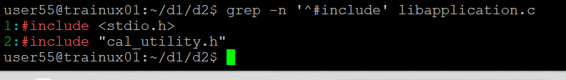

**b. display all lines which do not begin with #include**

**A: Command used---** grep -v ‘^#include’ filename

v—for not matching lines, ^ ---beginning of the line

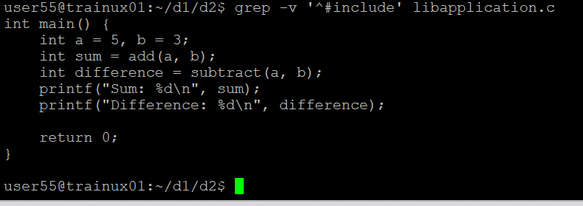

**c. display the line number of main()**

**A: Command used---** grep -n ‘main()’ filename

n—for line numbers

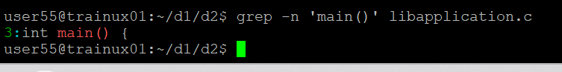

**d. extract all lines containing characters of opening and closing parathesis {(,))**

**A:Command used---** grep -n '[{}]' libapplication.c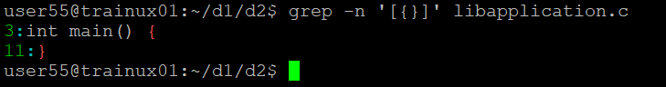

**2. Perform the above operations on a set of *.c files**

**A: Command used---** grep -n '^#include' *.c

grep -n ‘main()’ *.c

grep -v ‘^#include’ *.c